Batch: D2 Roll No.: 25

Experiment / assignment / tutorial No.___4___

Grade: AA / AB / BB / BC / CC / CD /DD

Signature of the Staff In-charge with date

**Title:** Support Reaction of Beam

CO1: Identify the effect of forces and moment in a given engineering system

CO3: Analyze applications of equilibrium using free body diagram

**Objective**

To verify the principle of forces in beams using parallel force apparatus

**Theory**

Beams are structural members which are generally horizontal. They are subjected to lateral forces which act orthogonal to the length of the member. There are various types of mechanisms used for supporting the beams. At these supports the reactive forces are developed which are determined by using the concept of equilibrium.

Determine the support reactions for the beam as

∑fxi = 0

∑fyi = 0

∑Mo = 0

**AIM:**

To find the support reaction of a simply supported beam analytically and verify the same experimentally.

**APPARATUS:**

A graduated beam supported at both the ends by spring balances, hangers and weights.

**Setup Diagram:**



**PROCEDURE:**

1. Take the initial readings of the spring balances at both the ends.
2. Suspend three known weights at different known distances from the left support of the beam.
3. Note the readings of the spring balances again.
4. The difference between the final and initial readings of the spring balances gives the reactions at the two supports.
5. Calculate the support reactions analytically.
6. Compare the same with the experimental values and find the percentage error on each of the support reactions. It is assumed that all the forces are coplanar and beam remains in the horizontal position even after loading.

**OBSERVATION TABLE:**

|  |  |  |  |  |  |  |  |  |  |  |  |  |
| --- | --- | --- | --- | --- | --- | --- | --- | --- | --- | --- | --- | --- |
| Set no | Forces acting (N) | | | Distances from R1 (cm) | | | Reactions by analysis (N) | | Reactions observed (N) | | % error in R1 | % error in R2 |
|  | F1 | F2 | F3 | X1 | X2 | X3 | R1 | R2 | R1 | R2 |  |  |
| 1 | 10 | 10 | 10 | 20 | 30 | 40 | 18.75 | 11.25 | 19.5 | 10 | 4% | 11.11% |
| 2 | 10 | 10 | 20 | 20 | 30 | 45 | 22.5 | 17.5 | 23.5 | 16 | 4.44% | 8.75% |
| 3 | 10 | 20 | 10 | 20 | 35 | 45 | 23.125 | 16.875 | 24 | 18 | 3.87% | 11.11% |

**CALCULATIONS:**

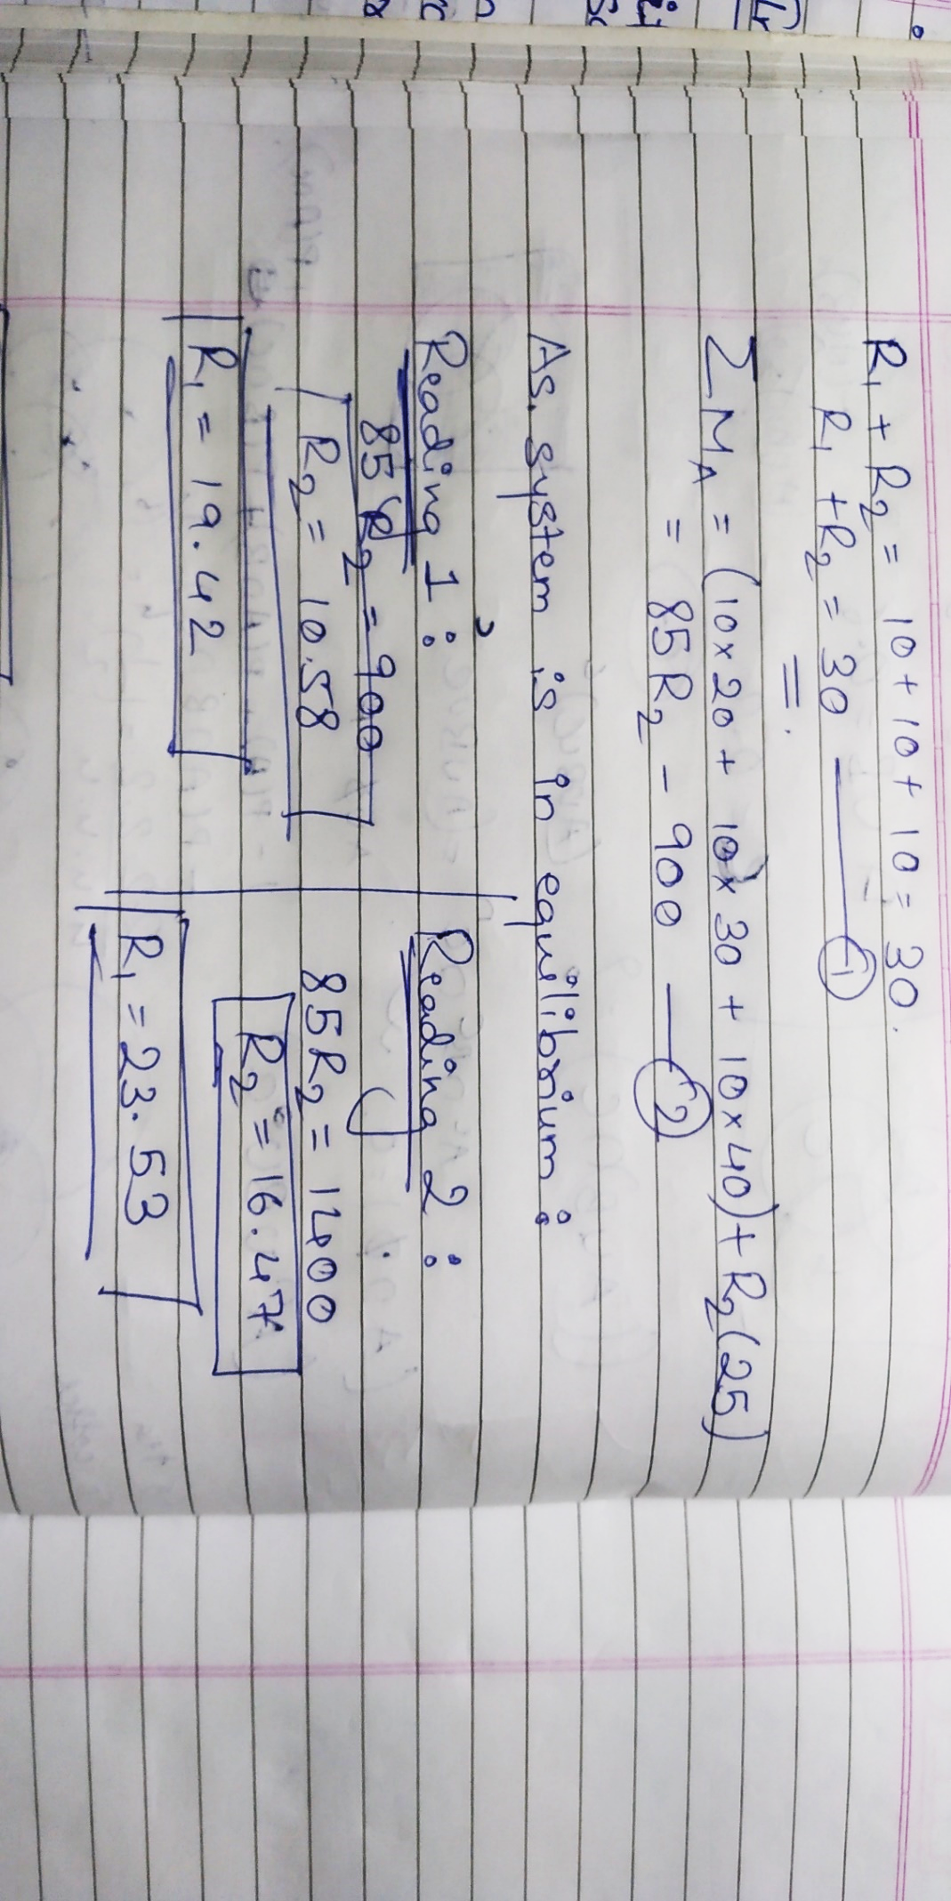

**RESULT:**

% error in R1 = 0.34%

% error in R2 = 4.63%

**Signature of faculty in-charge**